Requirements engineering
- Rob created a requirements table to reflect the current state of the requirements after the specification changes.
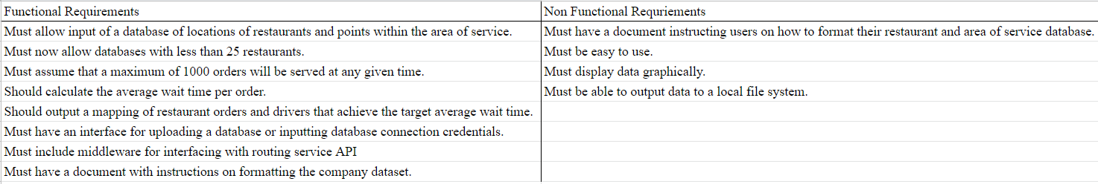

System Modeling
- Rob created a data flow diagram which illustrates how the input data is processed into business metrics
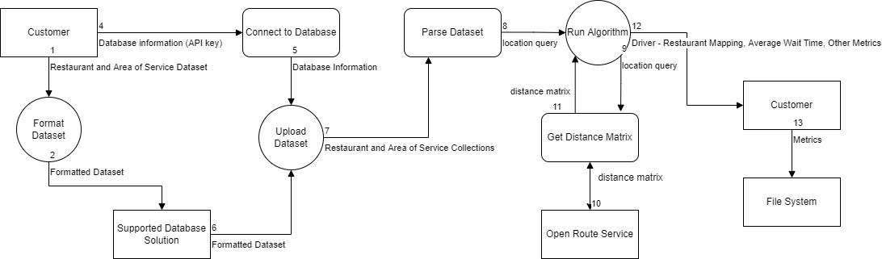
- Rob updated the use case diagram to reflect the changes made in the user interface which allows the user to specify the operation performed by the program
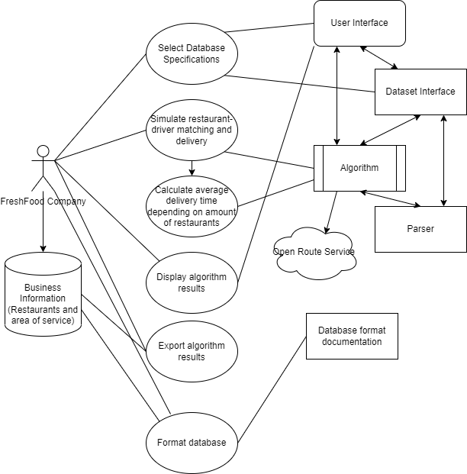
- Kiernan created State Diagram representing FreshTime
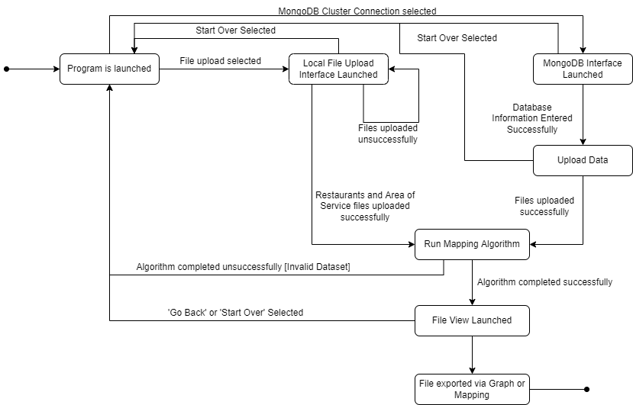
- Kiernan generated Sequence Diagram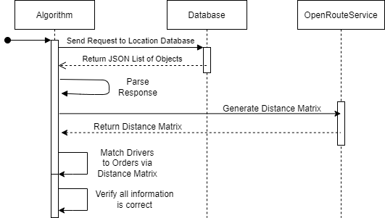

Architectural Design
- Rob created a process view for the FreshTime project architecture
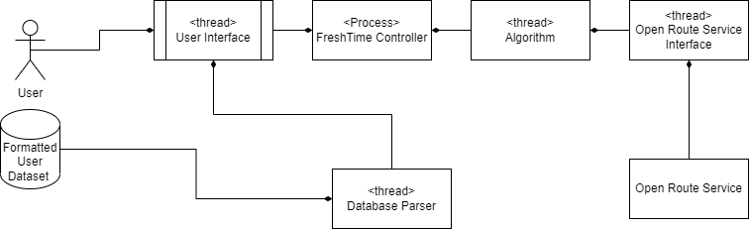
This shows how the system is made up of individual processes that spawn threads which perform a specific task.

Design Specification
- Rob updated Software Specification documents to reflect changes in the functional and nonfunctional requirements.
  - Identified supported databases, mongoDB and local file upload.
- Kiernan finalized the Database Import Specification Document in tandem with our chosen database architecture.
- Kiernan updated the current Javadoc comments for all classes.
- Kiernan generated Javadoc and uploaded it to Github.
- Kiernan drafted a Database Format Document.

- Wiktor created a class diagram
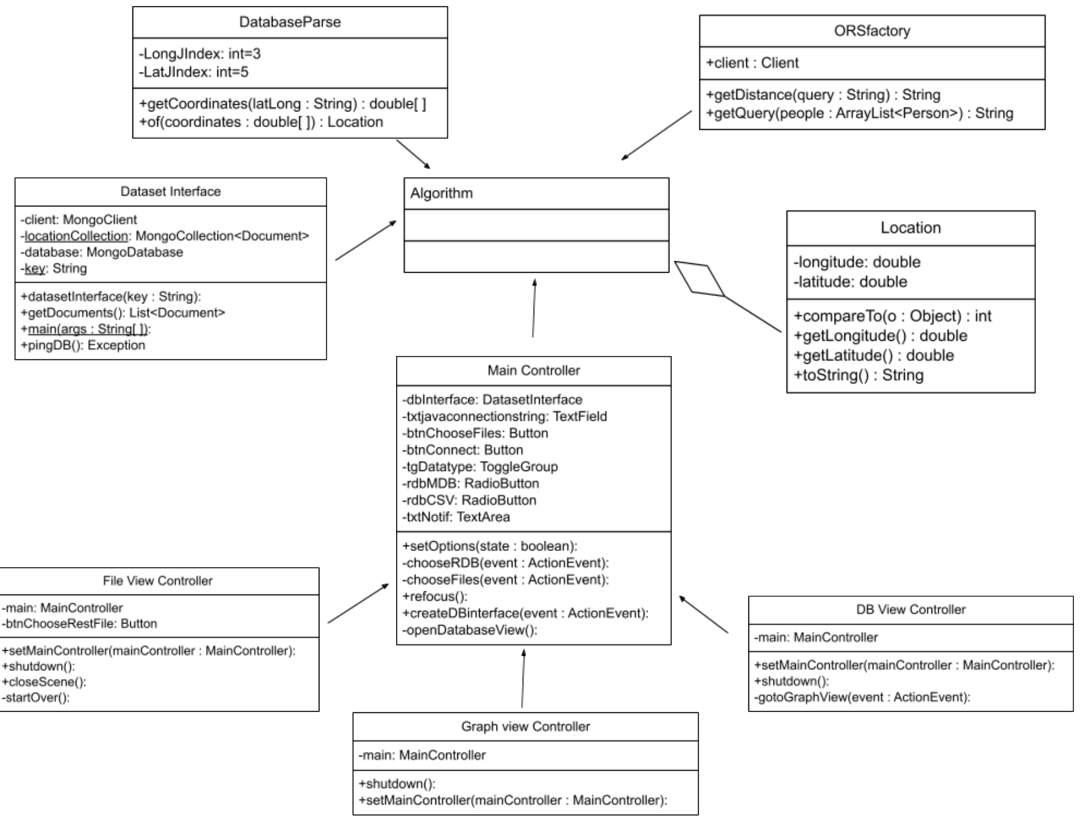
Design Implementation
- Kiernan uploaded a location database file (.csv) into our MongoDB database.
- Kiernan updated Interface, Algorithm and Parsing methods with code that better represents our project requirements.
- Rob added to the FreshTime project designing the user input checking system for valid symbols.

Software Testing (across all levels)
- Dan created a spreadsheet to compare the data returned from the ORSfactory class distance matrix times returned versus that of google maps.
- Dan drafted Junit tests which tested Rob’s getDistance method of the ORSfactory class which passed.
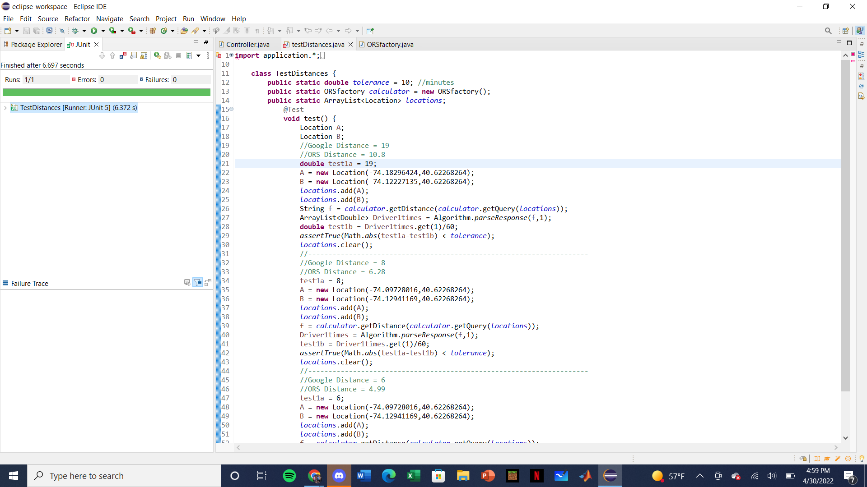
- Dan Created a document to test the GUI component of FreshTime.

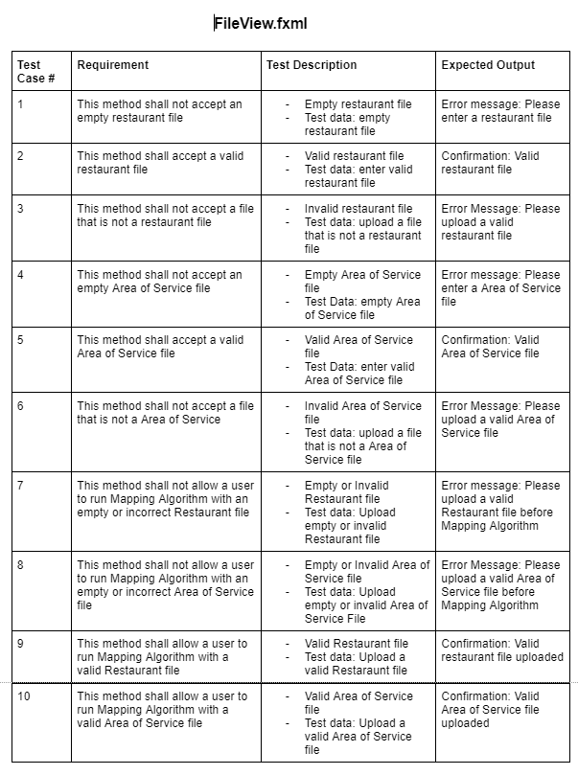
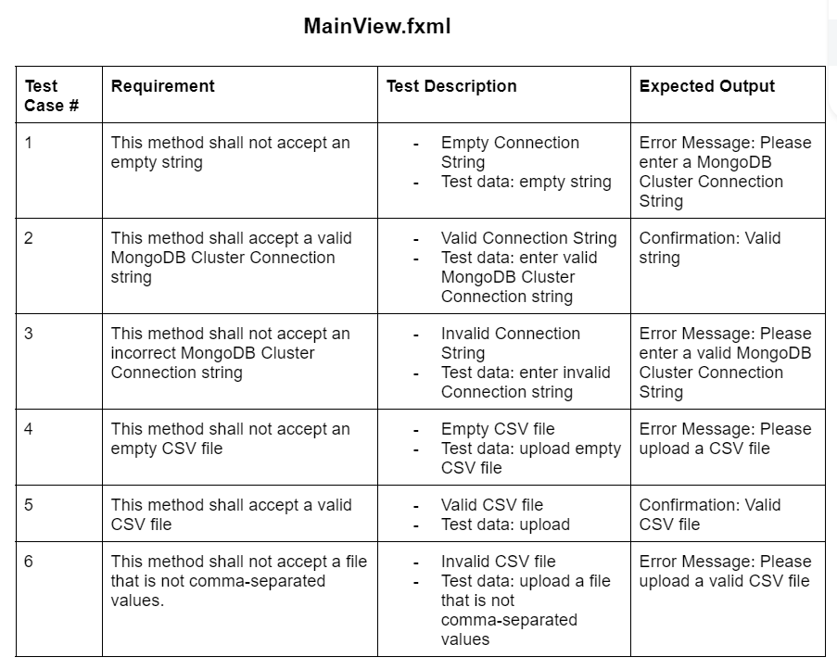

Dependable Attribute
Reliability - Brian has laid out plans to test all possible states of the GUI next week. The week after we have plans to test our Delivery Time Algorithm against valid and invalid conditions and inputs. These are indicated in the reliability plan document in the sprint 5 folder. These plans are intended to ensure the reliability of our program by having a formal code review process which stems from the initial system requirements and ensures they will be fulfilled and provide correct service to the user.

Project Management Concept
- Brian drafted a Software Quality Assurance Plan detailing the future development of the project.
  - SQA Plan_04/30/22

Advanced SWE topics
Distributed Software Engineering - Software as a Service (SaaS)
- Brian conducted research on the future possibility of developing a web based version of our software to offer as a service and then created the SaaS Customer Interaction Plan
FURTHER DETAILS in the “Software as a Service Plan” Document
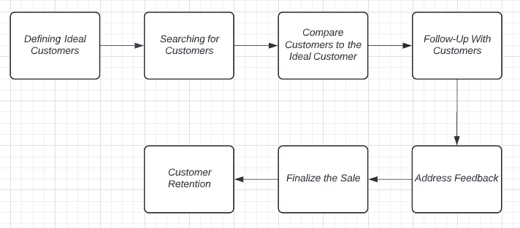

Real-time Software Engineering System Analysis
- Wiktor researched and created the process pipeline diagram and a real time system analysis document that outlines the analysis of time sensitive elements in our system.
